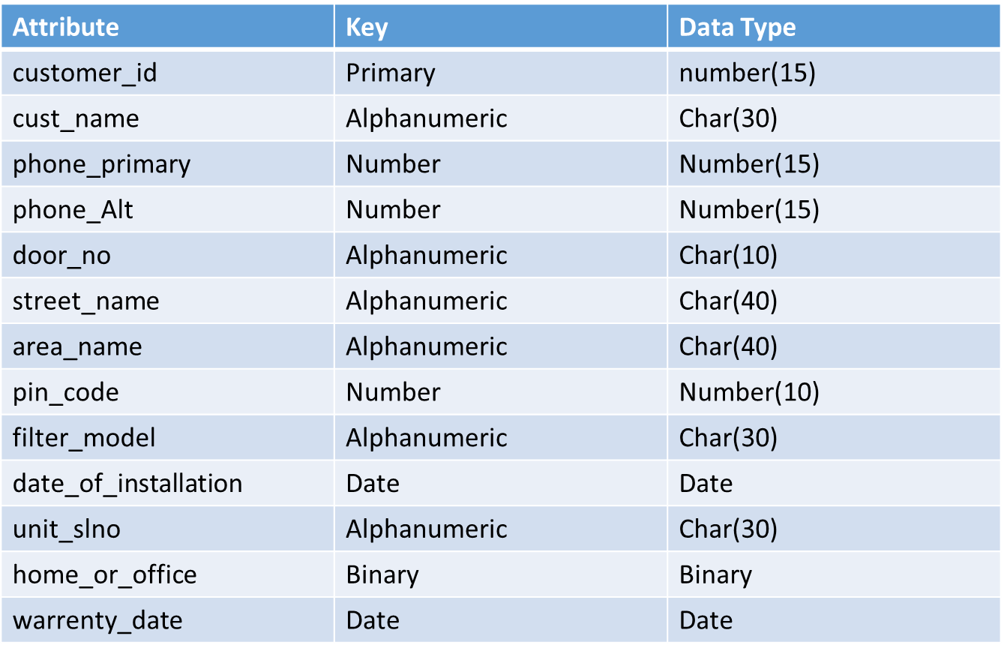
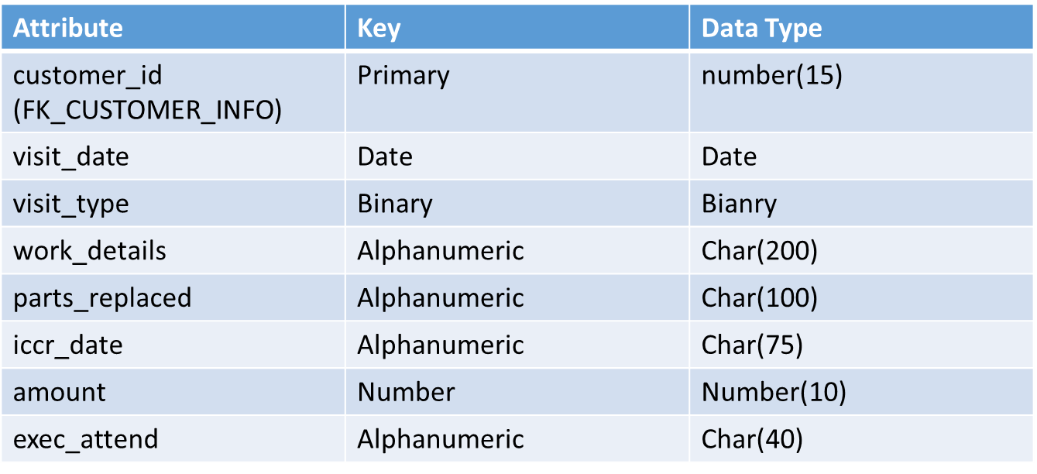
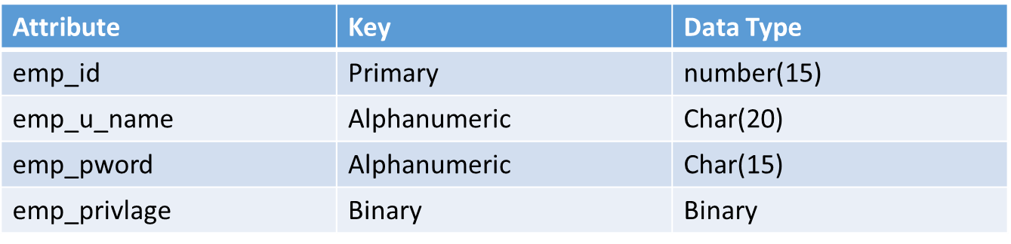
CUSTOMER_INFO
HISTORY_CARD
LOGIN_INFO

